Date:05/10/24

1.Installing the nginx and run nginx on port number 81

2.To change the index file,using the deployment location

Command :cd /usr/share/nginx/html/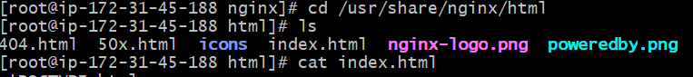

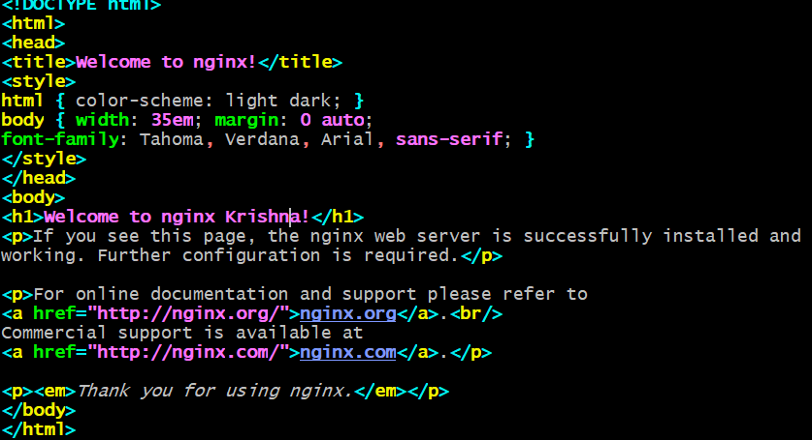

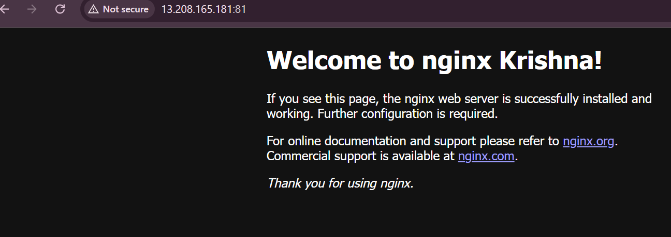

3. To change the default port number to 81

Command: /etc/nginx/nginx.conf

1.cd /etc/nginx

2.ls

3.cat nginx.conf



Change the listen to 81

After changing the port number,if we do netstat –na |grep 81

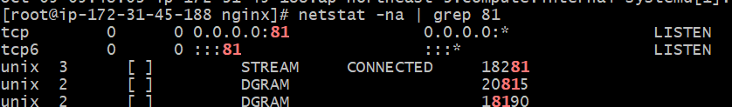

Final o/p:



2) 3) Install Apache and run Apache on port number 82

4) Deploy a sample index.html file on Apache.

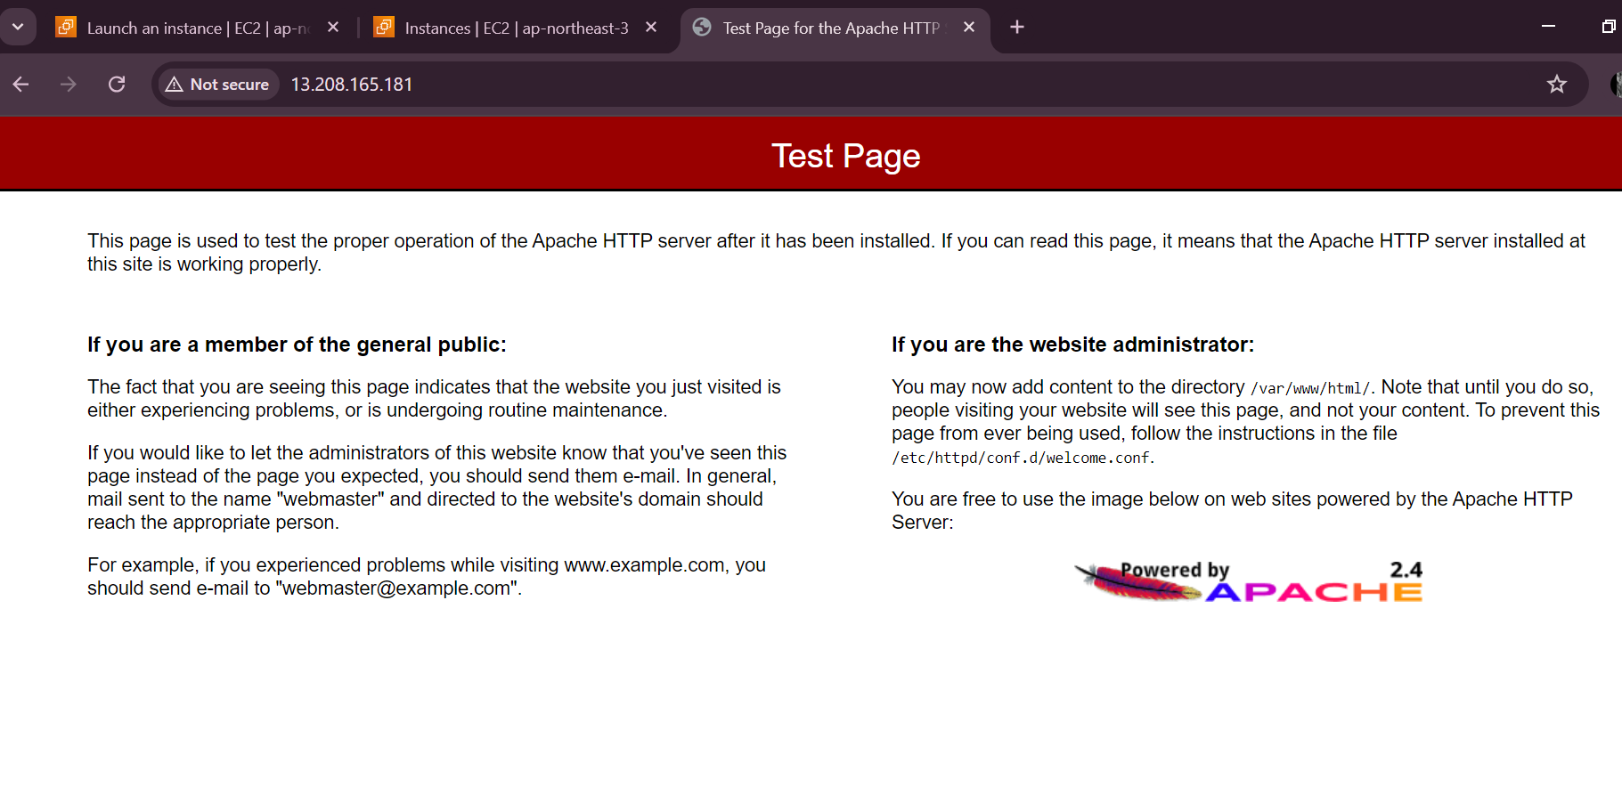

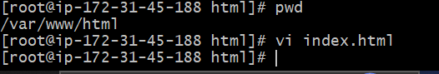



2)cmd:/etc/httpd/conf/httpd.conf

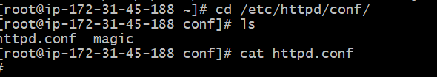

Cat the httpd .conf

Next, cmd:vi httpd.conf

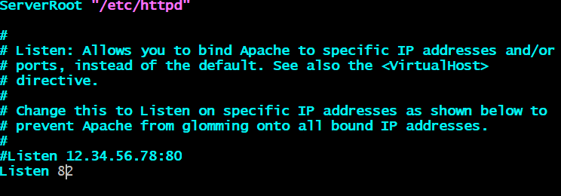

Save the changes and retart the httpd: systemctl restart httpd



5) Install Apache tomcat on port number 8082

Installing the apache tomcat

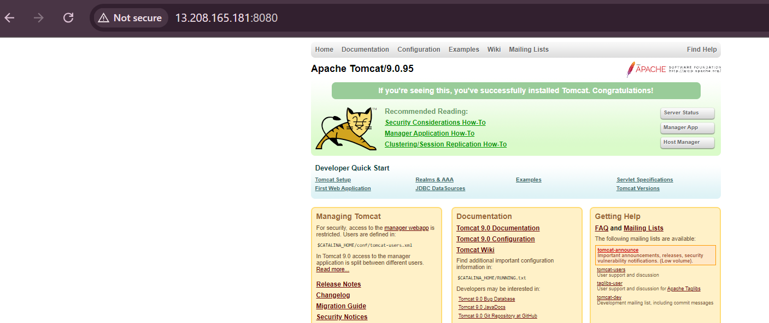

Running with port no:8082

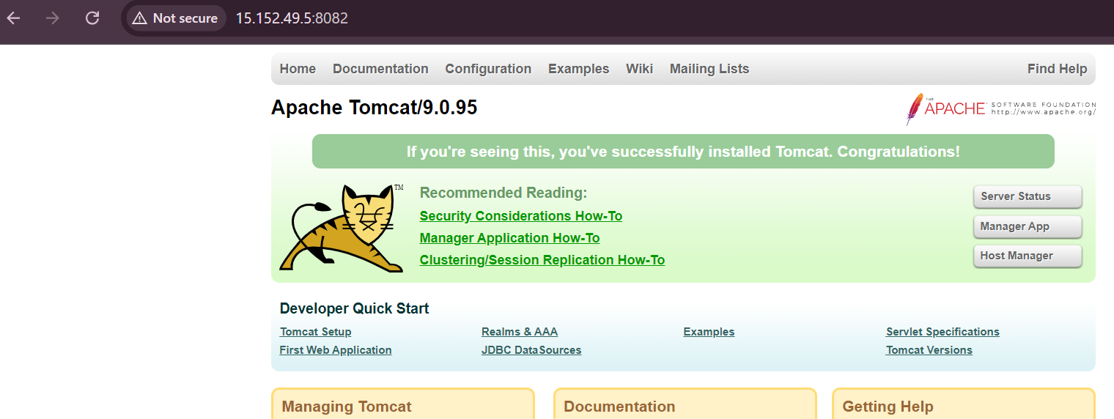

6) Deploy a sample app on webapps

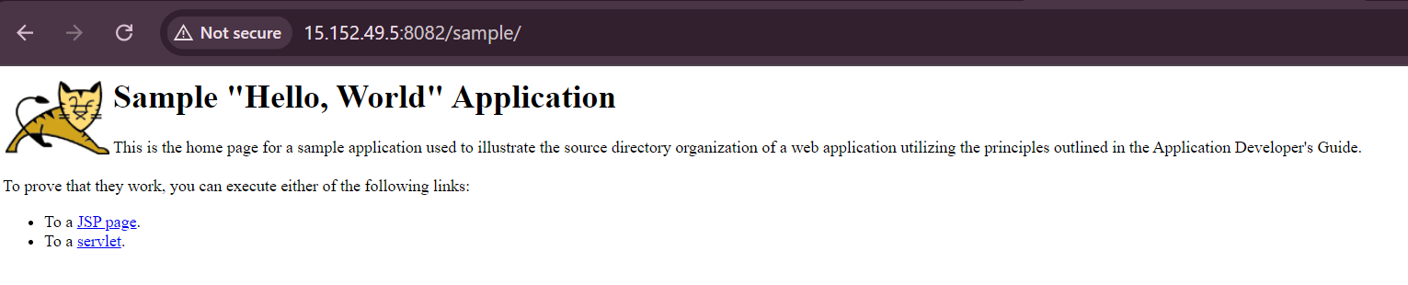

7) Create a tomcat.service file for tomcat.

Cmd: # vi /etc/systemd/system/tomcat.service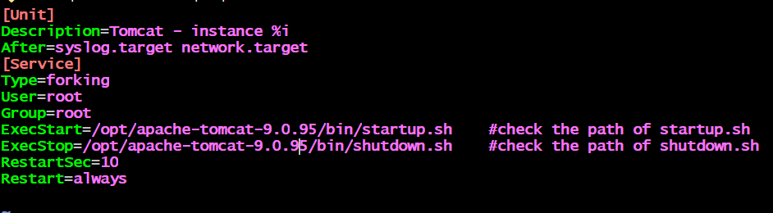

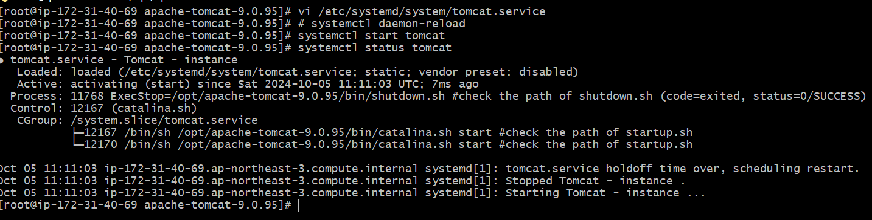

8) Configure HA Proxy server

Creating 3 servers on remote server

1.server-1

2.server-2

3.HA-PROXY server

1)connecting to server 1

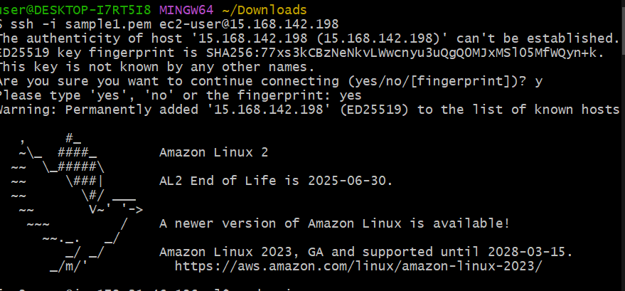

1)Installing apache,After installing running the below commands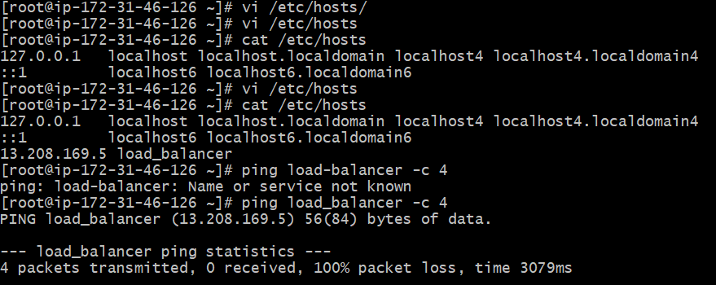

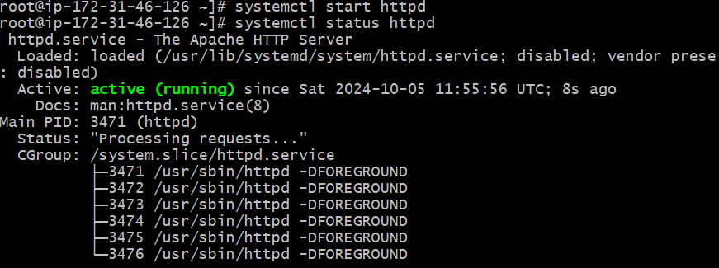

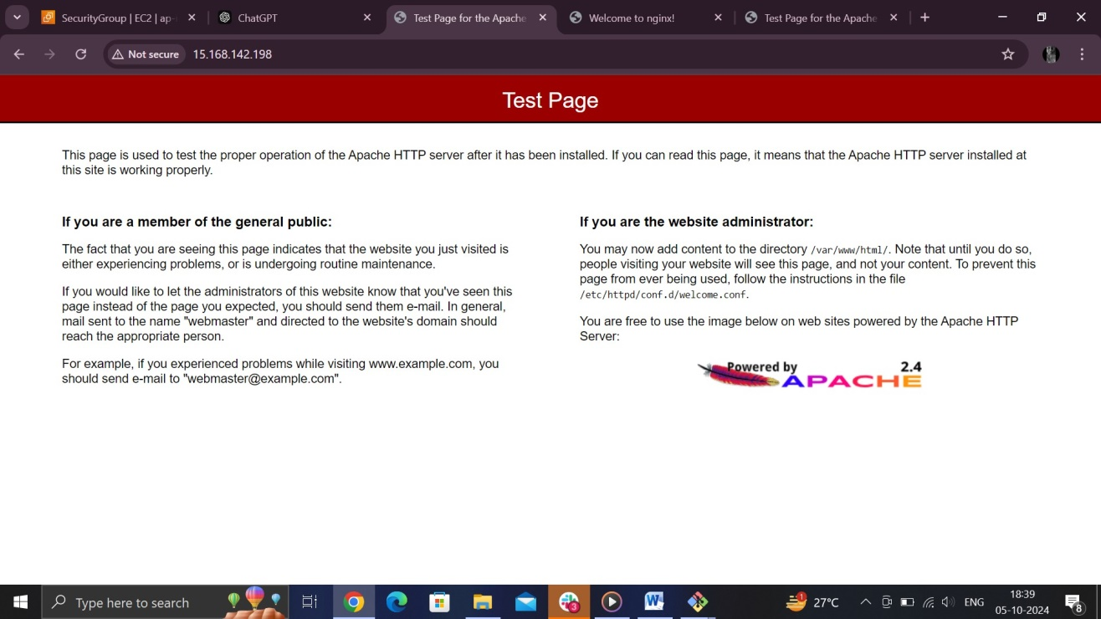

2)connecting to server 2

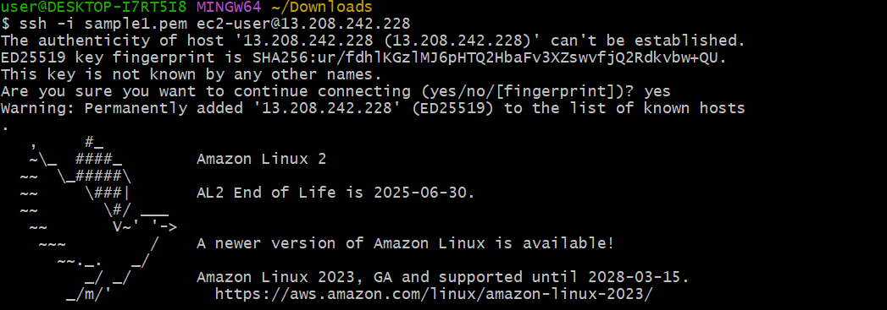



1.Installing the nginx and running the below commands

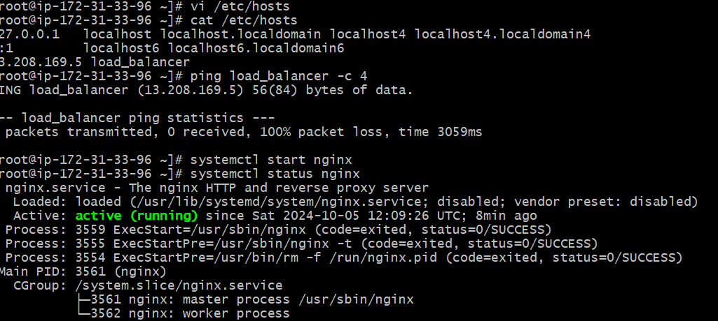

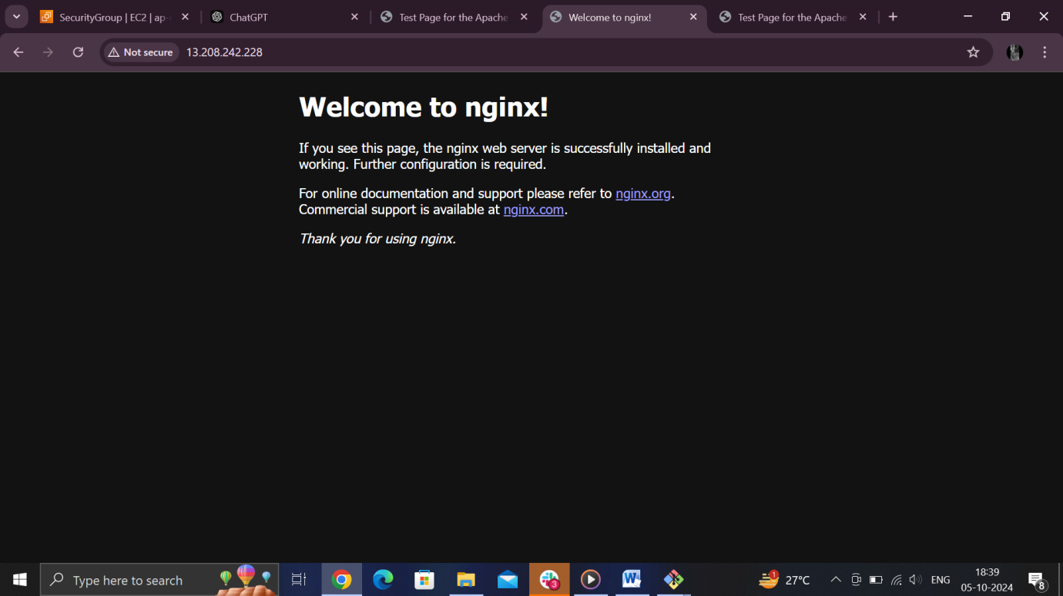

3)connecting to HA-PROXY server

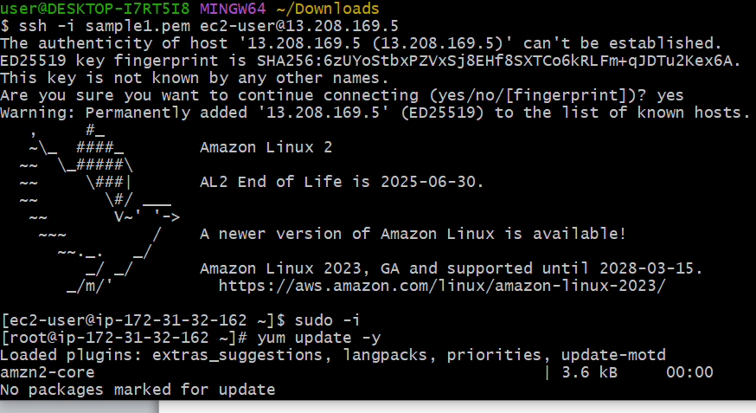

Installed the ha proxy server and running below commands

